NETWORK FUNDAMENTALS AND BUILDING NETWORKS

NETWORK CABLE AND CONNECTOR

TASK1: Draw a labeled diagram of a Cat6 Ethernet cable, showing the color order of wires in the T568B standard and labeling the RJ-45 connector pins.
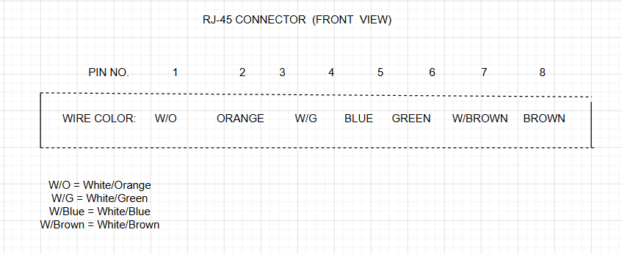

TASK2: List three types of network cables (such as Cat5e, Cat6, and fiber optic) and for each, mention one real-world app or device (like a WiFi router, Zomato POS terminal, or IPL streaming server) where it would be used, explaining why.
Cable Type | Example Device/App | Why It Is Used
Cat5e | Wi-Fi Router | Used for home internet connections up to 1 Gbps.
Cat6 | Gaming PC / Zomato POS Terminal | Provides faster speed and stable connection.
Fiber Optic | IPL Streaming Server | Used for very high-speed internet over long distances.

TASK3: Watch a YouTube video showing how to crimp an RJ-45 connector onto a network cable, then write down the step-by-step process in your own words and mention two common mistakes to avoid.
- Cut the network cable to the required length.
- Remove about 2–3 cm of the outer cable cover.
- Arrange the wires in the T568B color order.
- Straighten the wires and cut them evenly.
- Insert the wires into the RJ-45 connector.
- Make sure each wire reaches the end of the connector.
- Insert the connector into the RJ-45 crimping tool.
- Press the crimping tool firmly.
- Test the cable using a cable tester.
TWO COMMON MISTAKE TO AVOID :-
- Wrong wire color order.
- Wires not fully inserted into the RJ-45 connector.

TASK4: Given the following scenario: You are setting up a gaming zone for an IPL screening event and need to connect multiple screens and consoles. Choose the appropriate cable and connector types for high-speed, reliable connections, and explain your choices.
I would use Cat6 Ethernet cables with RJ-45 connectors to connect the gaming consoles and screens.
REASON:-
- Cat6 provides high-speed and stable connections.
- RJ-45 connectors are easy to install and work with Cat6 cables.
- This setup is reliable for gaming and IPL live streaming.
TASK5: Find and share a photo (from your home, college, or online) of any network cable or connector in use (such as behind a WiFi router or at a café's POS counter), and describe what type it is and what devices it connects.<br><br><em><strong>Hint:</strong> Look for blue or yellow cables with clear plastic ends (RJ-45) or thin round cables for fiber optics.</em>

